## Procedures

Canton Middle School

2018-2019

7th & 8th Grade Computer Syllabus

Ms. Rojas

## Assignments/Late /Re-Test Policies



**Course Description**

This is a 9 week computer class where students will create real-life documents to further develop and enrich their computer skills.

Students will learn the following skills:

• Word

• Excel

• Publisher

• Power Point



Attendance is critical; students cannot learn what they are not exposed to, both in rotation and in their core classes. Assignments are still due when you come back from an absence.

If you miss an assessment, you will take it on the day you return to school.

Do not be late to class.

**Remember, *you* *and only you* are responsible for any missed work**

1. When you enter the computer lab, pick up the day’s agenda from the teacher’s desk and sit at your assigned computer.

2. Remember the bell is not your signal to go. Ms. Rojas will dismiss you when everyone is quiet and seated.

3. **NO CELL PHONES** are allowed in class.

4. Consequences for not following proper school/classroom procedures may include: a phone call to your parents, detentions and or office referrals.

## Attendance

If you have questions, feel free to ask me any time!

email

**margaritarojas@u-46.org**

Please allow a 24 hour response time

**Classroom Expectations**  
1. Raise hand to speak.

2. Be on time and prepared; have all supplies and assignments.

3. DO NOT chew gum, eat food or candy, or any kind of drink in class.

4. Follow all written and oral directions.

5. Respect others and their property by staying on task, listening to others, not disturbing or distracting others.

6. Turn in work on time and completed neatly.

7. Take responsibility for your actions.

8. Take care of washroom needs during the 4 minute passing period.

6. **All work** must be done at school during class time. There is no take home work.



1. All assigned work is expected to be turned in on the due date.

2. Grading is as follows:

**40% Formative Grade**

**60% Summative Grade**

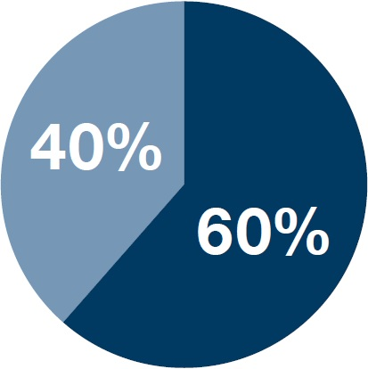

3. Grading scale will be in increments 4, 3, 2, 1, 0

4. Late work will be accepted up to the last date of this rotation grading period.

**5.** **Any mark 2 or lower on a summative assessment can be resubmitted following these guidelines:**

The maximum mark a student can earn on a

Re-test is 3.

Students who score

1or 0 on a **Summative Assessment** will automatically re-test the next school day.

|  |  |
| --- | --- |
| **Topic Score** | **Description of Scale** |
| 4 | I know it well enough to make these connections that weren’t taught, and I am right about those connections |
| 3 | I know everything that was taught, easy and hard parts, without making mistakes |
| 2 | I know all the easy parts but I make some mistakes on the harder parts |
| 1 | With help I know some of the easy parts and some of the harder parts |
| 0 | I don’t know any of it, or I have no proof of turned in |

|  |  |
| --- | --- |
| **Mark** | **Grade Meaning** |
| 4 | A - Mastery |
| 3 | B - Proficient |
| 2 | C - Basic |
| 1 | D - Below Basic |
| 0 | E - No evidence |

## U-46 Grading Scale

## Assignment Scores

**Extra Credit and Bonus Points**

To ensure that grades reflect progress toward and achievement of the standards, giving extra credit points or bonus points **WILL NOT** occur in this class. The vision of U-46 is that behavior/participation will be reported separately from academic achievement and is not a component of a student’s academic grade.

**I Have Read The Computer Syllabus**

Period ________

______________________________________ _______________________________________

Student Name Printed Student Signature

 ______________________________________ ___________________________

Parent Signature Date